Ampong Jemicho Louise B.

BSIT 32E2

1. (10 points) Write a C# program that calculates the area of a triangle given its base and height. Include user input for both values and display the calculated area.

**Answer:**

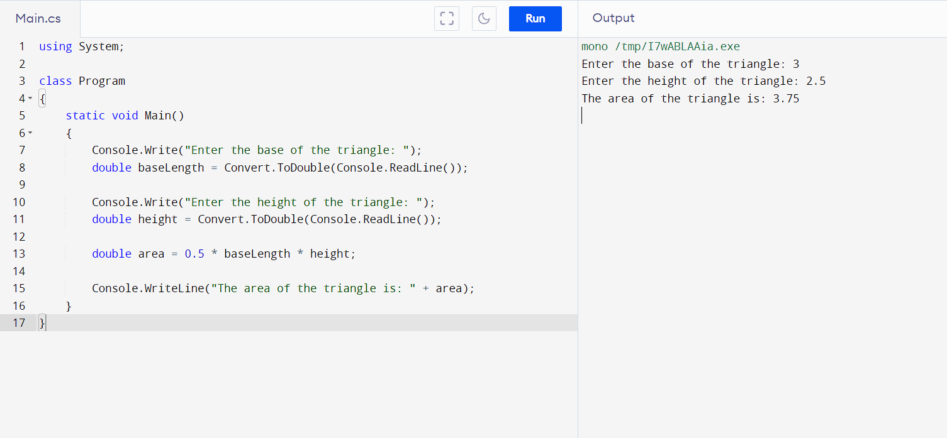

1. (10 points) Declare an array of 5 integers and fill it with values based on a user-defined formula (e.g., n^2). Then, print the largest element in the array.

**Answer:**

using System;

class Program

{

static void Main()

{

Console.Write("Enter a number to use as the formula (n^2): ");

int formulaNumber = Convert.ToInt32(Console.ReadLine());

int[] array = new int[5];

for (int i = 0; i < array.Length; i++)

{

array[i] = (i + 1) * formulaNumber;

}

int largestElement = FindLargestElement(array);

Console.WriteLine("The largest element in the array is: " + largestElement);

}

static int FindLargestElement(int[] array)

{

int largestElement = array[0];

for (int i = 1; i < array.Length; i++)

{

if (array[i] > largestElement)

{

largestElement = array[i];

}

}

return largestElement;

}

}

1. (10 points) Implement a simple for loop that iterates from 1 to 10 and prints each number along with its square root.

**Answer:**

using System;

class Program

{

static void Main()

{

for (int i = 1; i <= 10; i++)

{

double squareRoot = Math.Sqrt(i);

Console.WriteLine("The square root of " + i + " is " + squareRoot);

}

}

}

HTML

<!DOCTYPE html>

<html>

<head>

    <title>My Website</title>

    <link rel="stylesheet" href="styles.css">

    <script src="script.js"></script>

</head>

    <body>

        <h1>Welcome to...</h1>

        <p> This is a paragraph...</p>

        <img src="" alt="This is the image">

        <p> unordered list: </p>

            <ul>

                <li> Peenoise Podcast </li>

                <li> Pampamilya Premium </li>

                <li> PaoLUL </li>

            </ul>

        <p> ordered list: </p>

            <ol>

                <li> YouTube </li>

                <li> FaceBook </li>

                <li> Instagram </li>

            </ol>

        <p><a href="https://www.facebook.com">Click This </a> to redirect on YouTube.</p>

        <h3 class="Heading"> This is Heading 3 </h3>

        <button onclick="displayResult()"> Enter a Number </button>

        <p id="result"></p>

**CSS**

body {

    background-color: lightblue;

}

h1, h3 {

    padding: 20px;

}

p.tags {

    font-size: 14px;

}

ol {

    list-style-type: circle;

}

.Heading {

    color: red;

}

**HTML**

<!DOCTYPE html>

<html>

<head>

<title>Even or Odd</title>

</head>

<body>

<button onclick="checkNumber()">Check Number</button>

<p id="result"></p>

<script>

function isEvenOrOdd(num) {

if (num % 2 === 0) {

return "even";

} else {

return "odd";

}

}

function checkNumber() {

var num = prompt("Enter a number:");

var result = isEvenOrOdd(num);

document.getElementById("result").innerHTML = "The number is " + result;

}

</script>

</body>

</html>

**Javascript**

function isEvenOrOdd(num) {

if (num % 2 === 0) {

return "even";

} else {

return "odd";

}

}

1. Discuss the importance of object-oriented programming (OOP) concepts in software development. Explain the key principles of OOP (encapsulation, inheritance, polymorphism, abstraction) and provide examples of how they can be used to create more efficient, maintainable, and reusable code. Include real-world scenarios or cases where OOP is particularly valuable.

Answer:

**Object Oriented Programming** - Object-oriented programming (OOP) is a programming paradigm that is based on the concept of "objects", which can contain data and code that manipulates that data.

Key principles of OOP:

* **Encapsulation**: is the act of just providing a restricted interface for external interaction, keeping the inner workings of an object's implementation hidden.
* **Inheritance:** is the process of building a new class by copying the attributes and functions of an already-existing class. This can help to increase the software's consistency and maintainability while lowering the amount of code that needs to be written.
* **Polymorphism:** is the process of representing various object kinds with a single interface. This can aid in the software's simplification and increase its flexibility.
* **Abstraction:** The process of abstracting away an object's implementation details and concentrating on its interface is called abstraction. This may aid in streamlining the program and improving its usability.

Developers can produce code that is more effective, reusable, and manageable by following these guidelines. Polymorphism makes software more flexible and easier to use, abstraction makes software simpler and easier to comprehend, and encapsulation helps to increase security and dependability. Inheritance also minimizes the amount of code that has to be created.

// Encapsulation

class Person

{

private string name;

private int age;

private Address address;

public string Name

{

get { return name; }

set

{

if (string.IsNullOrEmpty(value))

{

throw new ArgumentException("Name cannot be null or empty.");

}

name = value;

}

}

public int Age

{

get { return age; }

set

{

if (value < 0)

{

throw new ArgumentException("Age cannot be negative.");

}

age = value;

}

}

public Address Address

{

get { return address; }

set { address = value; }

}

}

// Inheritance

class Student : Person

{

public int StudentId { get; set; }

public double Gpa { get; set; }

}

// Polymorphism

interface Shape

{

double GetArea();

}

class Circle : Shape

{

public double Radius { get; set; }

public double GetArea()

{

return Math.PI * Radius * Radius;

}

}

class Rectangle : Shape

{

public double Width { get; set; }

public double Height { get; set; }

public double GetArea()

{

return Width * Height;

}

}

// Abstraction

class BankAccount

{

public void Deposit(double amount)

{

// Process the deposit

}

public void Withdraw(double amount)

{

// Process the withdrawal

}

}